Project Request – A154
Allstate Insurance Company Street City, State Zip T 888.555.1234 F 888.555.1256 E someone@allstate.com
PREPARED BY: Rick Desiderio |  |  | DATE: 10/14/2013- Updated 5/23/2014 – Updated 7/15/14

PROJECT NAME: Allstate Mobile App – Endorsement Change Address, Change Auto

PROJECT NUMBER:

INTERNAL ORDER (I/0) NUMBER: 09688

PROJECT SPONSOR(S):

NAME | TITLE | DEPARTMENT |  | PHONE
Roger Tye | Director Consumer Engagement | Marketing, E-Business |  | x22893
Mike Antognoli | Senior Manager, Consumer Engagement | Marketing, E-Business |  | x22675

PROJECT CONTACT(S):
Rick Desiderio | Manager, Consumer Engagement | Marketing, E-Business | x23263

DESIRED START DATE (Quarter -Year): Q4 - 2013 DESIRED COMPLETION DATE: Q1 – 2014

PROJECT DESCRIPTION: (to indicate type, left mouse click box next to appropriate type)
TYPE: Incremental Compliance (Légal Mandate, etc.)
X Maintenance Other:

AGENT COMMUNITY IMPACTED? Yes X No Don’t Know

IMPACTED STATE/COMPANY/LINE: (Indicate all impacted State/Company/Line combinations in grid below)
STATE | COMPANY | LINE
All | n/a | n/a

Fill out this section (shaded with dotted border) if there is potential Product involvement.

GENERAL INFORMATION:
Are any of the states affected “Effective Date” states? N/A
If Yes, how will Future Effective Date (FED) policies be handled? Leave FED policies in force w/current rates
Terminate FED policies and re-issue as NB
Has the state mandated an effective date (indicate date if applicable)? N/A
Are any of the states affected Direct Distribution States? N/A
Do any of the states affected require prior approval for Rates? N/A for Forms?
Will hold cards be necessary for this project? N/A
Is a Business Transaction Checklist required for this project? N/A If Yes, please complete and attach.
Is a Credit Ordering Checklist required for this project? N/A If Yes, please complete and attach.
Are Current Carrier Database (CCDB) requirements impacted by this project? N/A
Will this project create new data fields that will need to be available for measurement, reporting, or analysis? NO
Was a Pre-Requirements Meeting held for this project? NO
If Yes, what was the date of the meeting?

Customer Experience Integration
Does this project change rates or coverages? NO
Does this project impact renewals? NO
If you answered yes to either of the questions above, please answer the following:
Will your project impact customers at New Business Renewals Other (END, SBO, etc.)
Wherever T-DOCS are required
How will your project impact Renewals?
How will your project impact premium paying customers?
How will we communicate changes to the customer?

PROJECT OBJECTIVE(S) AND BENEFITS: (Describe the business impact(s) that is expected as a result of the project)

Provide change policy (endorsement) functionality accessing the eGain process (to Charlotte Call Center) in order to provide the ability to change policy information on Address and Auto from your phone.

Use Cases

Scenario 1:

John Doe lives near the local highschool, he notices that when he gets home that sometimes his mail box is pulled open. Because he has not yet enrolled in Allstate® eBill and ePolicy, he decides to get a Post Office box in his home town. He wants to update is address, so he logs on to his Allstate(SM) Mobile App and completes the address change form on the Policy Change Section. He gets a notification on the screen that it may take 24-48 hours to complete. On the back-end the request is sent to eGain via the same process as My Account and it is then handled by a member of the Charlotte Internet Team.

Scenario 2:

Jane Doe decides to purchase a new car. She trades in her old car at the dealership and having all of the information in hand uses the Allstate(SM) Mobile app to do a policy change. She selects the car that she wants to replace and adds the new car information such as make, model, year VIN Number, number of miles driven, usage, etc. The form is a mobile version of the same form that My Account uses. She gets a notification on the screen that it may take 24-48 hours to complete. On the back-end the request is sent to eGain via the same process as My Account and it is then handled by a member of the Charlotte Internet Team.

DELIVERABLES: (Deliverable descriptions, including project scope)

Provide Endorsement Functionality that Mirrors the My Account features below specifically design for the Mobile App in both the Android and iPhone User Experice

-Mobile Change Address

-Mobile Add/Delete/Replace Auto

These are the various combinations
- Add a car form
- Delete a car form
- Replace a car (this form has the deletion of an old car and addition of a new car in the same form)

The Current Confirmation Emails sent: (1) the Confirmation Email when the transaction request is “submitted” and
(2) the Manually Triggered eGain email that confirmed that is has been “processed” - will need to be duplicated
with wording changes mentioning Mobile instead of My Account.

There have been and will be updates to the forms that currently are in place on My Account. Screens are added in line
From My Account to show the updates Mobile needs to keep pace with.

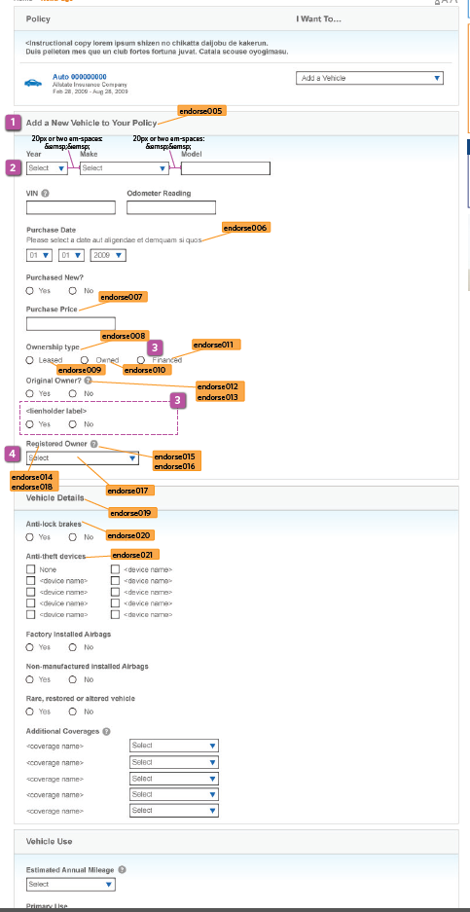
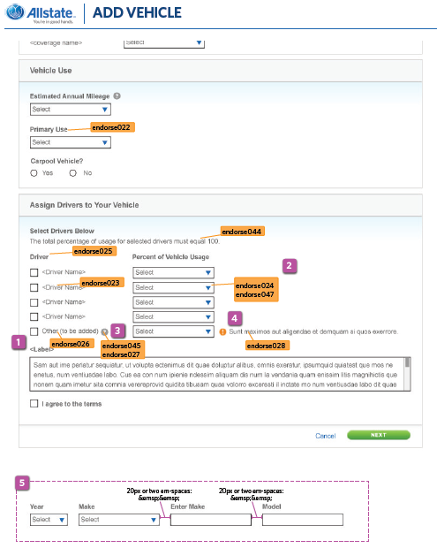

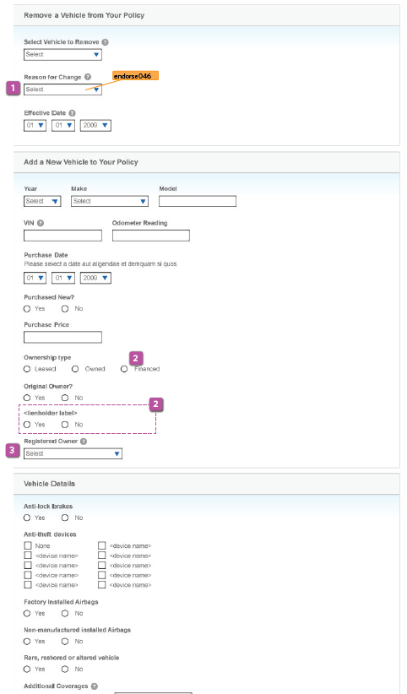

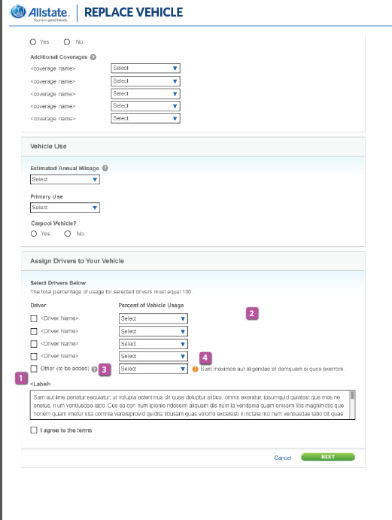

Additional background on changes – see Attachement:

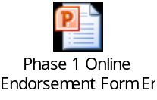

Business Issue: The CCC group that receives the My Account (and soon to be Mobile) endorsement request does not receive information within that request to indicate whether or not the vehicle being removed was enrolled in Drivewise. As such, there is a risk that the CCC will not confirm the loss of discount when responding to the inquiry, confirm with the customer next steps to take for their new vehicle (in the event of a replace vernicle endorsement), or request the customer return any devices installed in the vehicle (Drivewise 1.0 and 1.5).

Recommendation

  - Policy Enrolled in Drivewise 1.0 (Device for the Car – Device Discount) or 1.5 (Device in Car – Device Check)

    - Provide the customer with on-screen content informing them that the vehicle they are removing/replacing is enrolled in Drivewise

      - Remove Vehicle Scenario: If customer is enrolled in DW with their old vehicle, provide on-screen messaging to the customer to request they unplug the DW device, and confirm that an email will be sent shortly with instructions to return the device at no charge to them.

      - Replace Car Scenario: Same content as ‘Remove Vehicle’, but also instruct the customer that someone will get back to them with confirmation as to whether or not their new vehicle is eligible for DW, and if so, someone will provide details on how to switch out the device to the new vehicle so the customer can continue to participate in Drivewise

    - Pass an indicator with the request to the group receiving the endorsement request (i.e. CCC) to let them know if the old vehicle being removed / replaced was enrolled in Drivewise – we will need to confirm for the CCC that the enrollment was with the device.

      - Remove Vehicle Scenario: The CCC should be instructed to remind the customer to unplug their DW device from their old vehicle, and to inform the customer that an email will be sent to them shortly with instructions on how to return the device at no charge to them.

      - Replace Vehicle Scenario: Same content as ‘Remove Vehicle’, but the CCC should also confirm with the customer if their NEW vehicle is eligible for DW. If so, the CCC should encourage the customer to have them switch the device to their new vehicle to remain enrolled in DW and to keep their current savings if applicable– and to also confirm with the customer that an email confirmation will be sent to them when the DW device is installed in a new vehicle. The CCC should then ensure the Drivewise indicator on the new vehicle is set to Yes.

    - Pass an indicator with the request to the group receiving the endorsement request (i.e. CCC) to let them know if the new vehicle being added to a policy that was already enrolled in Drivewise.

      - Add Vehicle Scenario: If a customer is currently enrolled in Drivewise with an existing vehicle, when an ‘add vehicle’ request is sent to the CCC for review / processing we should also include an indicator to confirm that the customers policy is already enrolled in Drivewise – this should inform the CCC rep can confirm whether or not the customer is eligible to add Drivewise to the new vehicle, and if so, have that conversation with them when processing the request.

  - Policy Enrolled in Drivewise 2.0 (Mobile App Program)

    - Provide the customer with on-screen content informing them of the following:

      - Add Driver Scenario: Provide the customer with on-screen content if the customer is already enrolled in DW Mobile app program (i.e. Drivewise 2.0), instructing the customer to consider adding the new driver into the Drivewise program once the change has successfully been applied to their policy.

    - Pass an indicator with the request to the group receiving the endorsement request (i.e. CCC) when the policy in question is already enrolled in Drivewise 2.0 to let them know the following:

      - Add Driver Scenario: Provide the CCC rep with an indicator to confirm with the customer upon completion of the endorsement that once the driver is added to the policy the customer should consider logging into My Account to add the driver into the Drivewise program.

Endorsement Forms: Confirmation Page

Business Issue: Email and Phone number information captured online during the Endorsement Process is not stored in ICS – it is simply passed to the group who handles the endorsement.

Recommendation: Modify the endorsement confirmation page to allow a customer to select from a default list of phone numbers and email addresses when selecting their primary contact method.

  - Phone Number Dropdown:

    - Populate options with existing ICS Home, Work or Mobile numbers.
    - Allow for another option to provide a new number (request the user classifies the new number as Home, Work or Mobile.).
    - If the customer provides a new Home or Work number, pass it along with the endorsement request but ALSO overwrite it to the existing position in ICS.
    - If the customer provides a new mobile number, verify the number is indeed a mobile number and pass it along through the endorsement process.
    - TBD as to whether or not we update the ICS record given the potential impact to existing SMS Text enrollments leveraging that number).
      - Note: Agency and CCC applications drive the user to update the customer’s mobile phone number in the Preference Center – not sure that is the right experience for My Account endorsements – need to discuss during Analysis.

  - Email Address:

    - Default to the Primary email address on file.
    - If no email is on file for the Primary, ask for a new address.
    - If a new email address is provided pass it through the endorsement process but ALSO store it in ICS as the Primary email address.

RISKS IF NOT IMPLEMENTED: (What are the impacts to the organization and our customers if this project is not approved)

Customers will not have a key feature desired on the App .

ASSUMPTIONS: (Expectations regarding internal or external events, dependencies, etc.)

Use the same back-end process as My Account
CONCEPTUAL DESIGNS (optional): (Design document(s) which support the deliverable description above – may include links to other documents)

